# VISVESVARAYA TECHNOLOGICAL UNIVERSITY

## “Jnana Sangama”, Belagavi, Karnataka, India.



A Mini Project Report On

**Clipboard Application**

*Submitted in partial fulfillment of the requirement for VI Semester*

***Mobile Application Development Laboratory[18CSMP68]***

## in

**Computer Science and Engineering**

*Submitted By*

**Ashrith S D [1GA18CS033]**

**Ankenapalli Vamsi Kalyan Reddy [1GA18CS026]**

*Under the guidance of*

**Dr. KAVITHA K S, Professor**

**Prof. SOWMYA M, Assistant Professor**



**Department of Computer Science and Engineering**

**(Accredited by NBA 2019-2022)**

**GLOBAL ACADEMY OF TECHNOLOGY**

Rajarajeshwari Nagar, Bengaluru - 560 098

## 2020 – 2021

# ABSTRACT

Android’s Clipboard performs copying and pasting on different data types, such as text strings, images, binary stream data, and other complex data types. Clipboard does the copying and pasting operations within the same application and between multiple applications that have implemented the clipboard framework. Clipboard has a limitation on the number of clip objects it can hold at a time. The clipboard can hold only one object at a time. If an object is put on the clipboard, the previously held object on the clipboard is dropped. The clip object can take in three types of data:

Text: A string can directly be put into the clip object and then into the clipboard. We can then get the clip object from the clipboard and paste the string into the application’s text or storage fields.

URL: It is used for copying complex data from the content provider. A URI object can be put into a clip object and then loaded onto the clipboard. To perform a paste operation, the clip object must be resolved into the source, such as a content provider.

Intent: An intent object must be created and put into a clip object and loaded onto the clipboard. Paste action, similar to the text, can be performed.

**IMPLEMENTATION**

**Program code:**

XML Code:

<?xml version="1.0" encoding="utf-8"?>

<androidx.constraintlayout.widget.ConstraintLayout xmlns:android="http://schemas.android.com/apk/res/android"

xmlns:app="http://schemas.android.com/apk/res-auto"

xmlns:tools="http://schemas.android.com/tools"

android:layout_width="match_parent"

android:layout_height="match_parent"

tools:context=".MainActivity">

<TextView

android:id="@+id/textView3"

android:layout_width="wrap_content"

android:layout_height="wrap_content"

android:text="Text copied from Clipboard"

android:textAllCaps="true"

android:textColor="#F10959"

android:textColorHighlight="#292626"

android:textSize="16sp"

android:textStyle="bold"

app:layout_constraintBottom_toBottomOf="parent"

app:layout_constraintEnd_toEndOf="parent"

app:layout_constraintHorizontal_bias="0.338"

app:layout_constraintStart_toStartOf="parent"

app:layout_constraintTop_toTopOf="parent"

app:layout_constraintVertical_bias="0.541" />

<TextView

android:id="@+id/textView"

android:layout_width="wrap_content"

android:layout_height="wrap_content"

android:text="ClipBoard Activity"

android:textAllCaps="true"

android:textColor="#009688"

android:textColorHighlight="#494343"

android:textSize="24sp"

android:textStyle="bold"

app:layout_constraintBottom_toBottomOf="parent"

app:layout_constraintEnd_toEndOf="parent"

app:layout_constraintHorizontal_bias="0.453"

app:layout_constraintStart_toStartOf="parent"

app:layout_constraintTop_toTopOf="parent"

app:layout_constraintVertical_bias="0.049" />

<EditText

android:id="@+id/TxtCopy"

android:layout_width="287dp"

android:layout_height="59dp"

android:ems="10"

android:inputType="textPersonName"

app:layout_constraintBottom_toBottomOf="parent"

app:layout_constraintEnd_toEndOf="parent"

app:layout_constraintHorizontal_bias="0.427"

app:layout_constraintStart_toStartOf="parent"

app:layout_constraintTop_toTopOf="parent"

app:layout_constraintVertical_bias="0.304" />

<EditText

android:id="@+id/TxtPaste"

android:layout_width="285dp"

android:layout_height="57dp"

android:ems="10"

android:inputType="textPersonName"

app:layout_constraintBottom_toBottomOf="parent"

app:layout_constraintEnd_toEndOf="parent"

app:layout_constraintHorizontal_bias="0.423"

app:layout_constraintStart_toStartOf="parent"

app:layout_constraintTop_toTopOf="parent"

app:layout_constraintVertical_bias="0.627" />

<Button

android:id="@+id/BtnCopy"

android:layout_width="wrap_content"

android:layout_height="wrap_content"

android:text="Copy to clipboard"

android:textSize="12sp"

app:layout_constraintBottom_toBottomOf="parent"

app:layout_constraintEnd_toEndOf="parent"

app:layout_constraintHorizontal_bias="0.068"

app:layout_constraintStart_toStartOf="parent"

app:layout_constraintTop_toTopOf="parent"

app:layout_constraintVertical_bias="0.857" />

<Button

android:id="@+id/BtnPaste"

android:layout_width="wrap_content"

android:layout_height="wrap_content"

android:text="Paste on Screen"

android:textSize="12sp"

app:layout_constraintBottom_toBottomOf="parent"

app:layout_constraintEnd_toEndOf="parent"

app:layout_constraintHorizontal_bias="0.891"

app:layout_constraintStart_toStartOf="parent"

app:layout_constraintTop_toTopOf="parent"

app:layout_constraintVertical_bias="0.857" />

<TextView

android:id="@+id/textView2"

android:layout_width="wrap_content"

android:layout_height="wrap_content"

android:text="Enter text to be copied to Clipboard"

android:textAllCaps="true"

android:textColor="#F10959"

android:textColorHighlight="#E91E63"

android:textSize="16sp"

android:textStyle="bold"

app:layout_constraintBottom_toBottomOf="parent"

app:layout_constraintEnd_toEndOf="parent"

app:layout_constraintHorizontal_bias="0.503"

app:layout_constraintStart_toStartOf="parent"

app:layout_constraintTop_toTopOf="parent"

app:layout_constraintVertical_bias="0.249" />

</androidx.constraintlayout.widget.ConstraintLayout>

Java Code:

package com.example.clipboard;

import androidx.appcompat.app.AppCompatActivity;

import android.content.ClipData;

import android.content.ClipboardManager;

import android.os.Bundle;

import android.view.View;

import android.widget.Button;

import android.widget.EditText;

import android.widget.Toast;

public class MainActivity extends AppCompatActivity implements View.OnClickListener{

Button b1,b2;

EditText t1,t2;

ClipboardManager myClipboard;

@Override

protected void onCreate(Bundle savedInstanceState) {

super.onCreate(savedInstanceState);

setContentView(R.layout.activity_main);

t1=findViewById(R.id.TxtCopy);

t2=findViewById(R.id.TxtPaste);

b1=findViewById(R.id.BtnCopy);

b1.setOnClickListener(this);

b2=findViewById(R.id.BtnPaste);

b2.setOnClickListener(this);

myClipboard= (ClipboardManager)getSystemService(CLIPBOARD_SERVICE);

}

public void onClick(View v)

{

if(v.equals(b1))

{

ClipData myClip;

String data = t1.getText().toString();

myClip = ClipData.newPlainText("text", data);

myClipboard.setPrimaryClip(myClip);

Toast.makeText(getBaseContext(),"Copied..",Toast.LENGTH_LONG).show();

}

else if(v.equals(b2))

{

ClipData abc = myClipboard.getPrimaryClip();

ClipData.Item item = abc.getItemAt(0);

t2.setText(item.getText().toString());

}

}

}

**RESULTS**

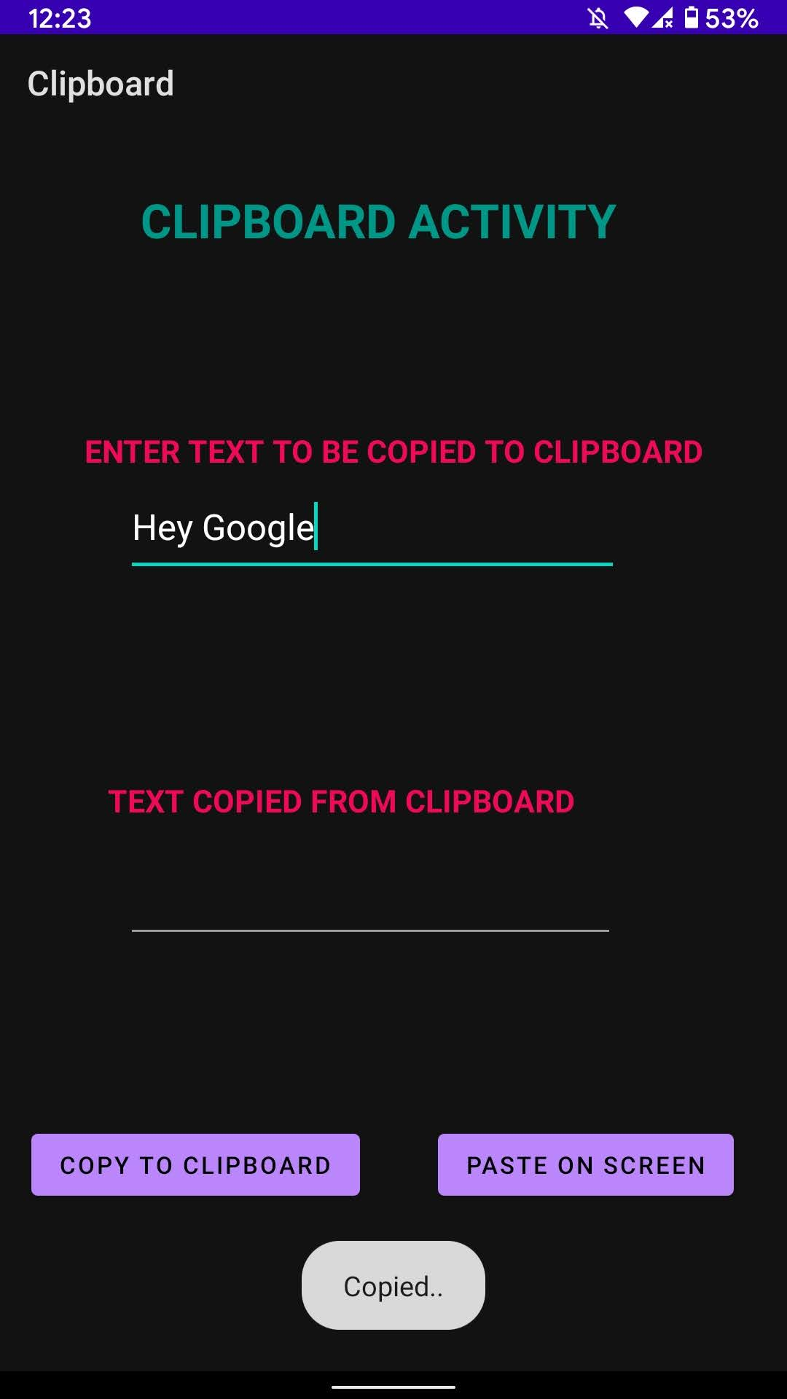

***Snapshot 1: The text to be copied to Clipboard has been entered and the button is clicked***

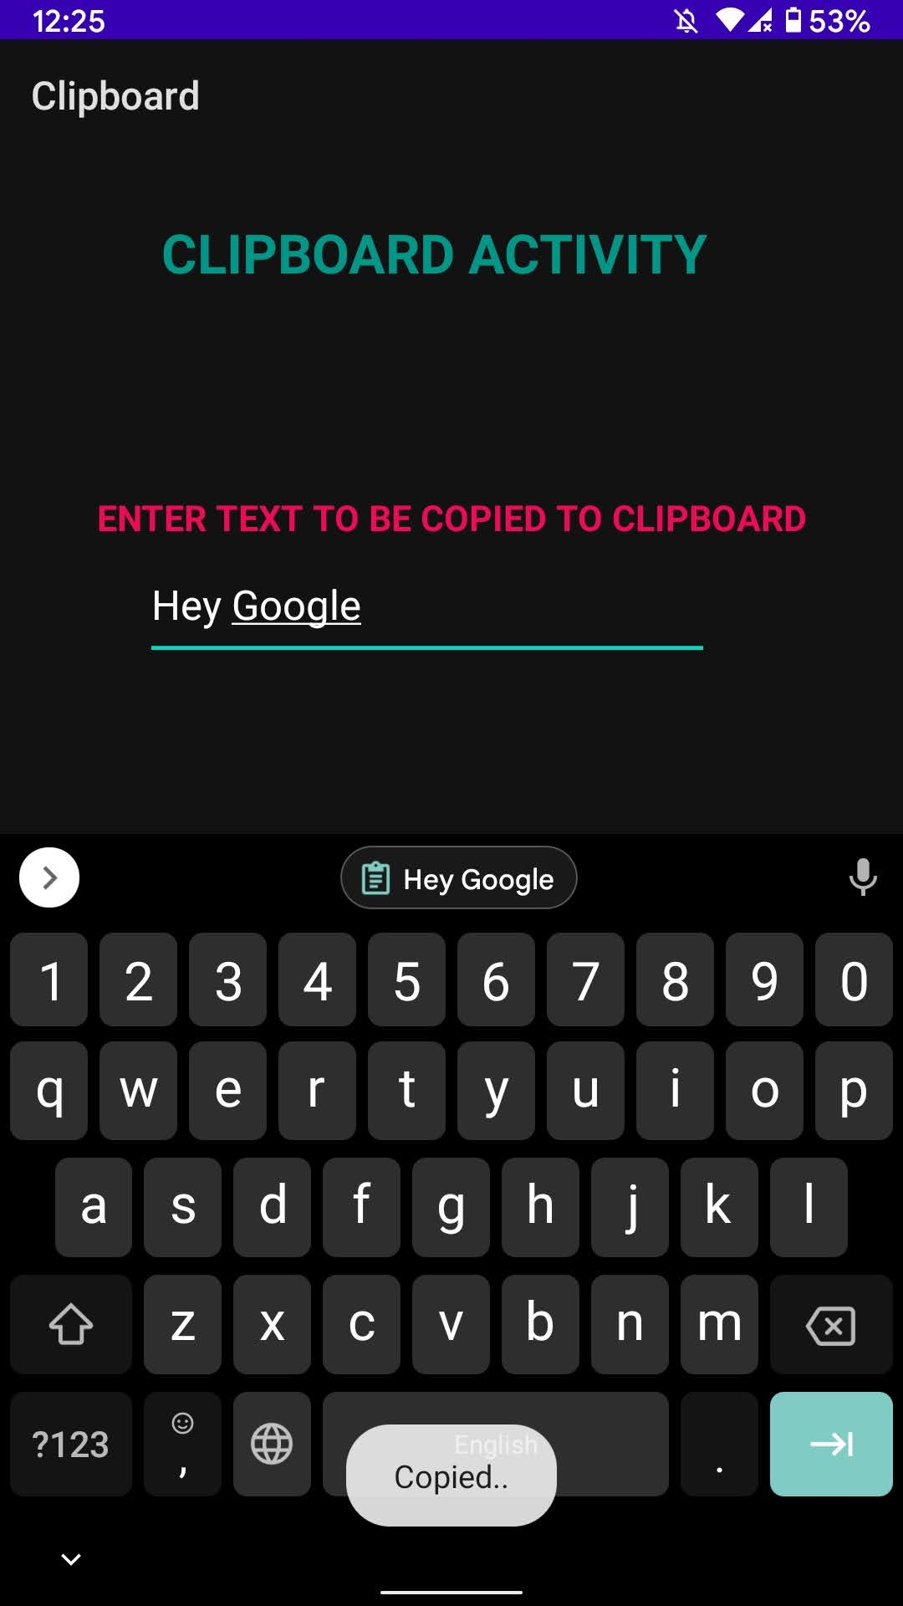

***Snapshot 2: The entered text has been copied to Clipboard***

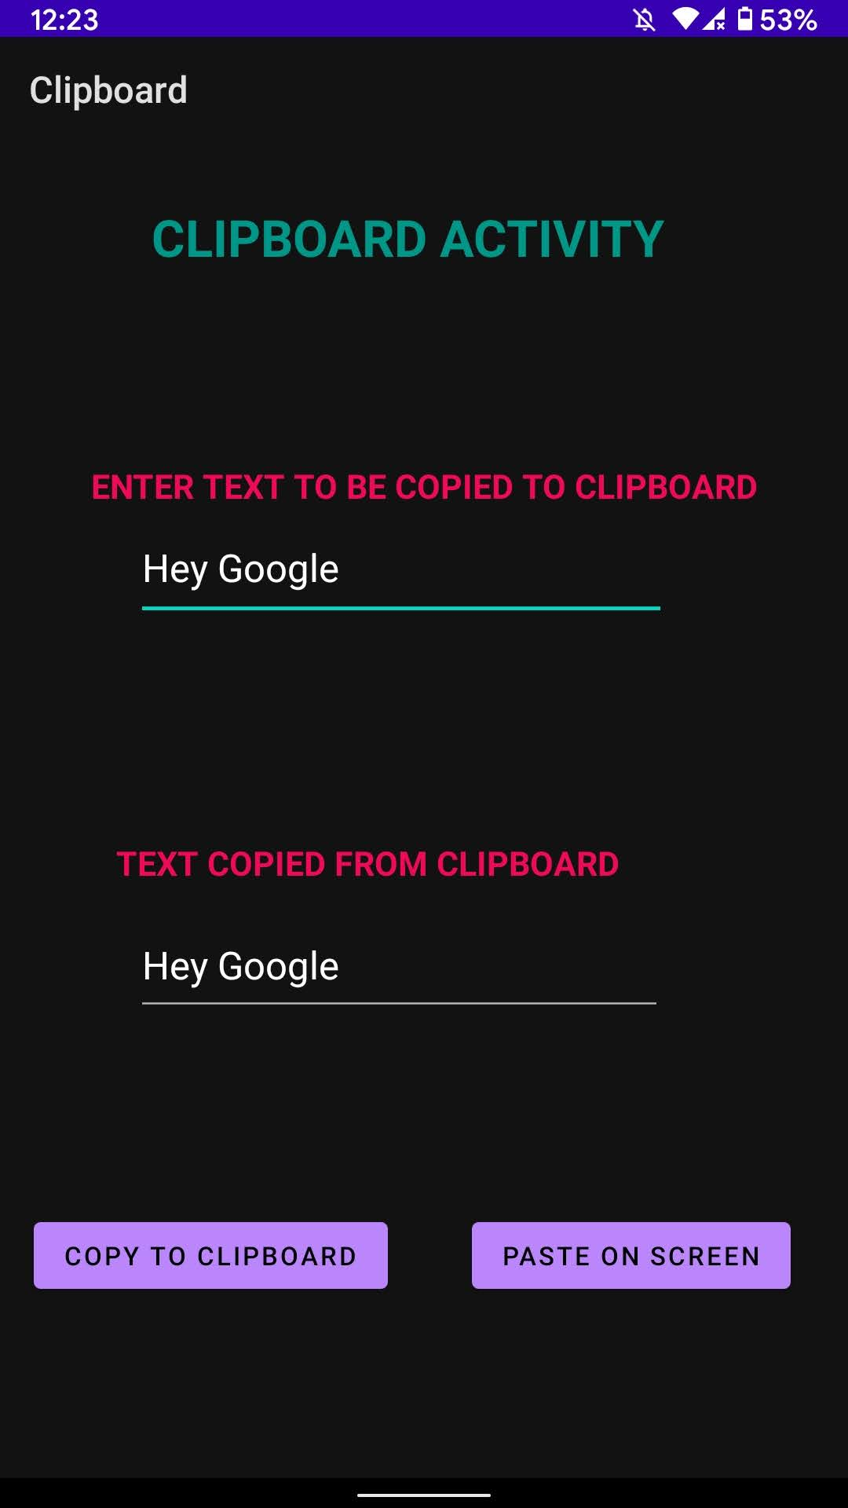

***Snapshot 3: The text copied from Clipboard has been pasted***